The first query counts the total number of products available in the product table, which helps understand the size of the inventory.
The second query calculates the total amount spent by each user by summing order values and grouping them by user_id.
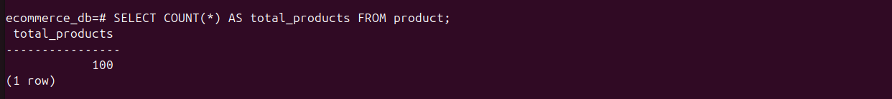

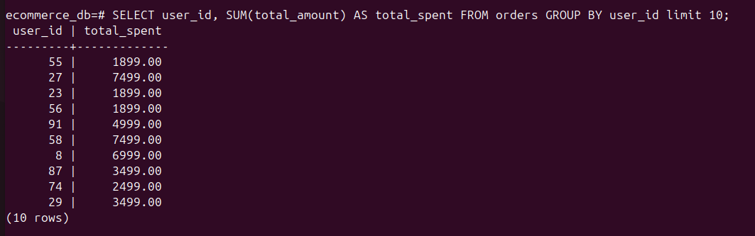

This query is used to find high-spending users by calculating the total order amount for each user. It groups orders by user_id and uses the HAVING clause to display only those users whose total spending is greater than 8000.

